Federated Traffic Sign Recognition under Non-IID Label Distributions:
A Reproducible Study of FedAvg and FedProx
Lucy Ma
Final Report

Abstract
Federated learning enables multiple clients to train a shared model without centralising raw data, but heterogeneous client distributions can reduce global performance. This study investigated label skew in federated traffic-sign recognition and evaluated whether FedProx could mitigate the resulting degradation. Experiments used the 43-class German Traffic Sign Recognition Benchmark with five simulated clients. Centralised, Local-only, and IID FedAvg baselines were established before Dirichlet partitions with α = 10, 1.0, 0.5, and 0.1 were used to create increasing heterogeneity. Under IID, FedAvg achieved 92.60% test accuracy and 89.44% macro-class accuracy. Performance remained stable under mild and moderate skew, but at α = 0.1 test accuracy fell to 71.49%, macro-class accuracy fell to 69.42%, and several classes reached zero accuracy. In strictly matched FedProx experiments, changing μ from 0 to 0.1 improved test accuracy from 77.51% to 84.52% and macro-class accuracy from 73.60% to 80.79% at α = 0.1; both metrics also improved at α = 0.5. The findings show that FedAvg is robust to limited label heterogeneity, while proximal regularisation can partially mitigate stronger skew.

1. Introduction
Traffic-sign recognition is an important perception task in intelligent transportation and automated-driving systems. Vehicles must identify speed limits, warnings, prohibitions, and mandatory signs before this information can support safe decision-making. Training accurate models usually requires images collected from many vehicles and locations. Centralising these images, however, may create privacy, ownership, storage, and communication concerns. Federated learning provides an alternative in which clients retain local data, perform local training, and transmit model updates to a coordinating server [1], [5].
A central difficulty is that client data are rarely independent and identically distributed. Vehicles travelling on different roads or in different regions may observe very different sign categories. One client may contain many speed-limit signs, while another contains mainly warnings or prohibitions. This label skew can make local optimisation directions inconsistent. When FedAvg aggregates the updates, the global model may become biased towards categories that dominate particular clients. Overall accuracy can also hide this behaviour because frequent classes contribute more test samples than rare classes. Macro-class and per-class accuracy are therefore important for identifying class-level degradation.
FedProx was proposed to address statistical and systems heterogeneity by adding a proximal term to each client's local objective [2]. The term penalises excessive movement away from the current global model and may reduce local overfitting when client distributions differ. Its effect must nevertheless be evaluated with a matched control: a comparison using different optimisers, learning rates, or initialisations would not isolate the contribution of the proximal term.
This study examined federated classification on the German Traffic Sign Recognition Benchmark (GTSRB) [3]. It addressed three questions: whether FedAvg provides a reliable IID baseline; how overall and class-level performance change as Dirichlet label skew becomes stronger; and whether FedProx improves performance under strong skew when all other training conditions are fixed. The main contributions are a reproducible five-client pipeline, a controlled heterogeneity analysis across four Dirichlet settings, and paired comparisons between μ = 0 and μ = 0.1. Rather than treating all Non-IID data as equally harmful, the report identifies a practical robustness boundary for FedAvg and evaluates where proximal regularisation becomes beneficial.

2. Methodology

2.1 Dataset and Client Partitions
Experiments used the GTSRB dataset, with 39,209 training images and 12,630 official test images across 43 classes [3]. Images were decoded as RGB, resized to 32 × 32 pixels, converted to float32, and normalised to [0, 1]. Horizontal flipping was excluded because it can change the meaning of directional signs. The official test set was isolated from client partitioning and hyperparameter selection.
Five simulated clients were created with a fixed partition seed of 20260720. The IID baseline used class-stratified partitioning, giving every client all 43 classes and a similar number of samples. For the Non-IID experiments, each class was distributed across clients using a symmetric Dirichlet distribution, following a common approach for creating continuously varying label skew [4].
p_c ~ Dirichlet(α, …, α)
The values α = 10, 1.0, 0.5, and 0.1 represented increasing heterogeneity. Smaller α values concentrated individual classes on fewer clients. Every partition was saved as fixed client CSV files and reused across algorithms, rather than being resampled during each comparison.

2.2 Model and FedAvg Baselines
All main experiments used the same convolutional neural network without Batch Normalisation: Conv32 → MaxPool → Conv64 → MaxPool → Conv128 → Global Average Pooling → Dropout(0.25) → Dense(43). An earlier Batch-Normalisation model produced unreliable global performance because non-trainable moving statistics were not consistently maintained in the federated pipeline. Excluding Batch Normalisation removed this implementation confound from the main comparisons.
The IID study compared centralised training, independent Local-only training, and weighted FedAvg. Centralised training used all training data in one pipeline. Local-only training produced one separate model per client without aggregation. FedAvg weighted each client contribution by its number of local examples. The Stage 1A and Stage 1B FedAvg experiments used all five clients in every round, one local epoch, batch size 64, client-side Adam with learning rate 0.001, server learning rate 1.0, and 160 communication rounds.

2.3 Strictly Paired FedProx Experiments
FedProx modifies each local objective by adding a proximal penalty:
L_k(w) = L_task,k(w) + (μ / 2) ‖w − wᵗ‖²
Here, wᵗ is the global model received at the beginning of a communication round. When μ = 0, the proximal term disappears and provides a FedAvg-equivalent control within the same trainer. Formal experiments were conducted on the α = 0.1 and α = 0.5 partitions, comparing μ = 0 with μ = 0.1 while fixing the initial model, client data, client order, optimiser, server update, training budget, and evaluation procedure. Both configurations used client-side SGD with learning rate 0.1 and zero momentum, server learning rate 1.0, five of five clients per round, one local epoch, batch size 64, and 160 rounds. Learning-rate and μ screening used validation results only; the official test set was evaluated after the configuration had been frozen.

2.4 Evaluation and Reproducibility
Ten per cent of each client partition was reserved for validation, and these subsets were combined for global model selection. The checkpoint with the highest global validation accuracy was used for final testing. Reported metrics included test accuracy, test loss, macro-class accuracy, per-class accuracy, confusion matrices, and learning curves. Macro-class accuracy gave equal weight to all 43 classes and was used to reveal failures that could be hidden by overall accuracy.
The pipeline saved experimental configurations, per-round metrics, best and final checkpoints, and test outputs. Additional checks verified fixed partitions, identical Round-0 weights in paired experiments, finite model updates, continuous checkpoint resumption, and sample-weighted server aggregation. Because the formal experiments used one random seed, confidence intervals and statistical-significance tests were not reported.

3. Results and Analysis

3.1 IID Baseline Performance
Table 1. Performance under the IID partition.
Method | Test Accuracy | Macro-class Accuracy
Centralised | 91.16% | 88.44%
Local-only mean | 60.11% | 49.67%
FedAvg | 92.60% | 89.44%

The five Local-only models achieved a mean test accuracy of 60.11% and a mean macro-class accuracy of 49.67%, indicating that an individual client's data were insufficient for generalisation across the complete official test set. FedAvg achieved 92.60% test accuracy and 89.44% macro-class accuracy, substantially outperforming Local-only training and reaching a level comparable to centralised training. FedAvg slightly exceeded the centralised model, but the result should not be interpreted as evidence of inherent superiority because the training budgets differed: centralised training used 30 epochs, whereas FedAvg used 160 rounds with one local epoch per round.

3.2 Effect of Label Heterogeneity on FedAvg
Figure 1 illustrates the contrast between mild and extreme label skew. Under α = 10, most classes were spread across the five clients. Under α = 0.1, many classes were concentrated on one or two clients, leaving other clients with few or no examples of those classes.
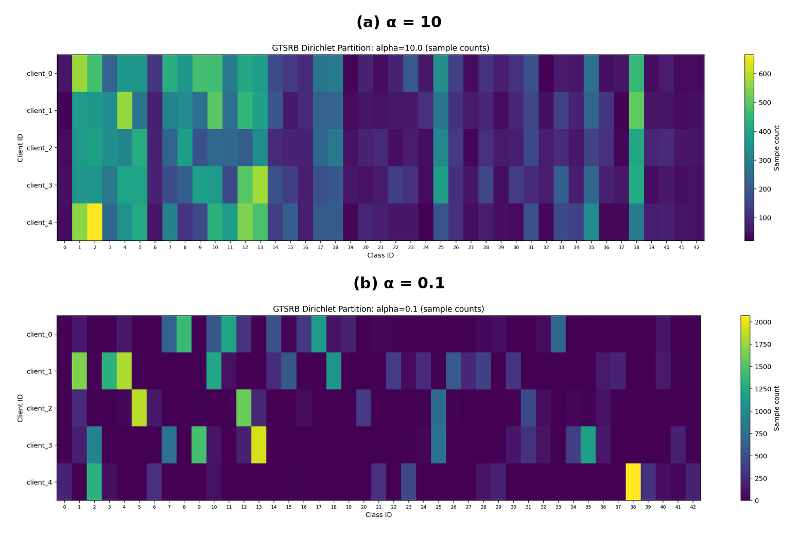
Figure 1. Client-level class counts under (a) mild and (b) extreme label heterogeneity. Smaller α concentrates individual classes on fewer clients.
Table 2. FedAvg performance across Dirichlet partitions.
Partition | Mean JS Divergence | Test Accuracy | Macro-class Accuracy
IID | 0.0000 | 92.60% | 89.44%
α = 10 | 0.0085 | 92.39% | 89.38%
α = 1.0 | 0.0880 | 92.60% | 89.49%
α = 0.5 | 0.1338 | 91.77% | 87.27%
α = 0.1 | 0.3148 | 71.49% | 69.42%

FedAvg remained stable under α = 10 and α = 1.0, where both metrics were close to the IID baseline. At α = 0.5, test accuracy decreased by only 0.83 percentage points, but macro-class accuracy decreased by 2.17 percentage points. The larger class-balanced decline suggests that uneven class behaviour appeared before the overall metric changed substantially.
The strongest degradation occurred at α = 0.1. Test accuracy fell by 21.12 percentage points relative to IID, and macro-class accuracy fell to 69.42%. Classes 0, 8, 19, 38, and 39 achieved zero accuracy, while the confusion matrix showed repeated errors between particular class pairs. The failure was therefore systematic rather than a small, uniform reduction across all classes.
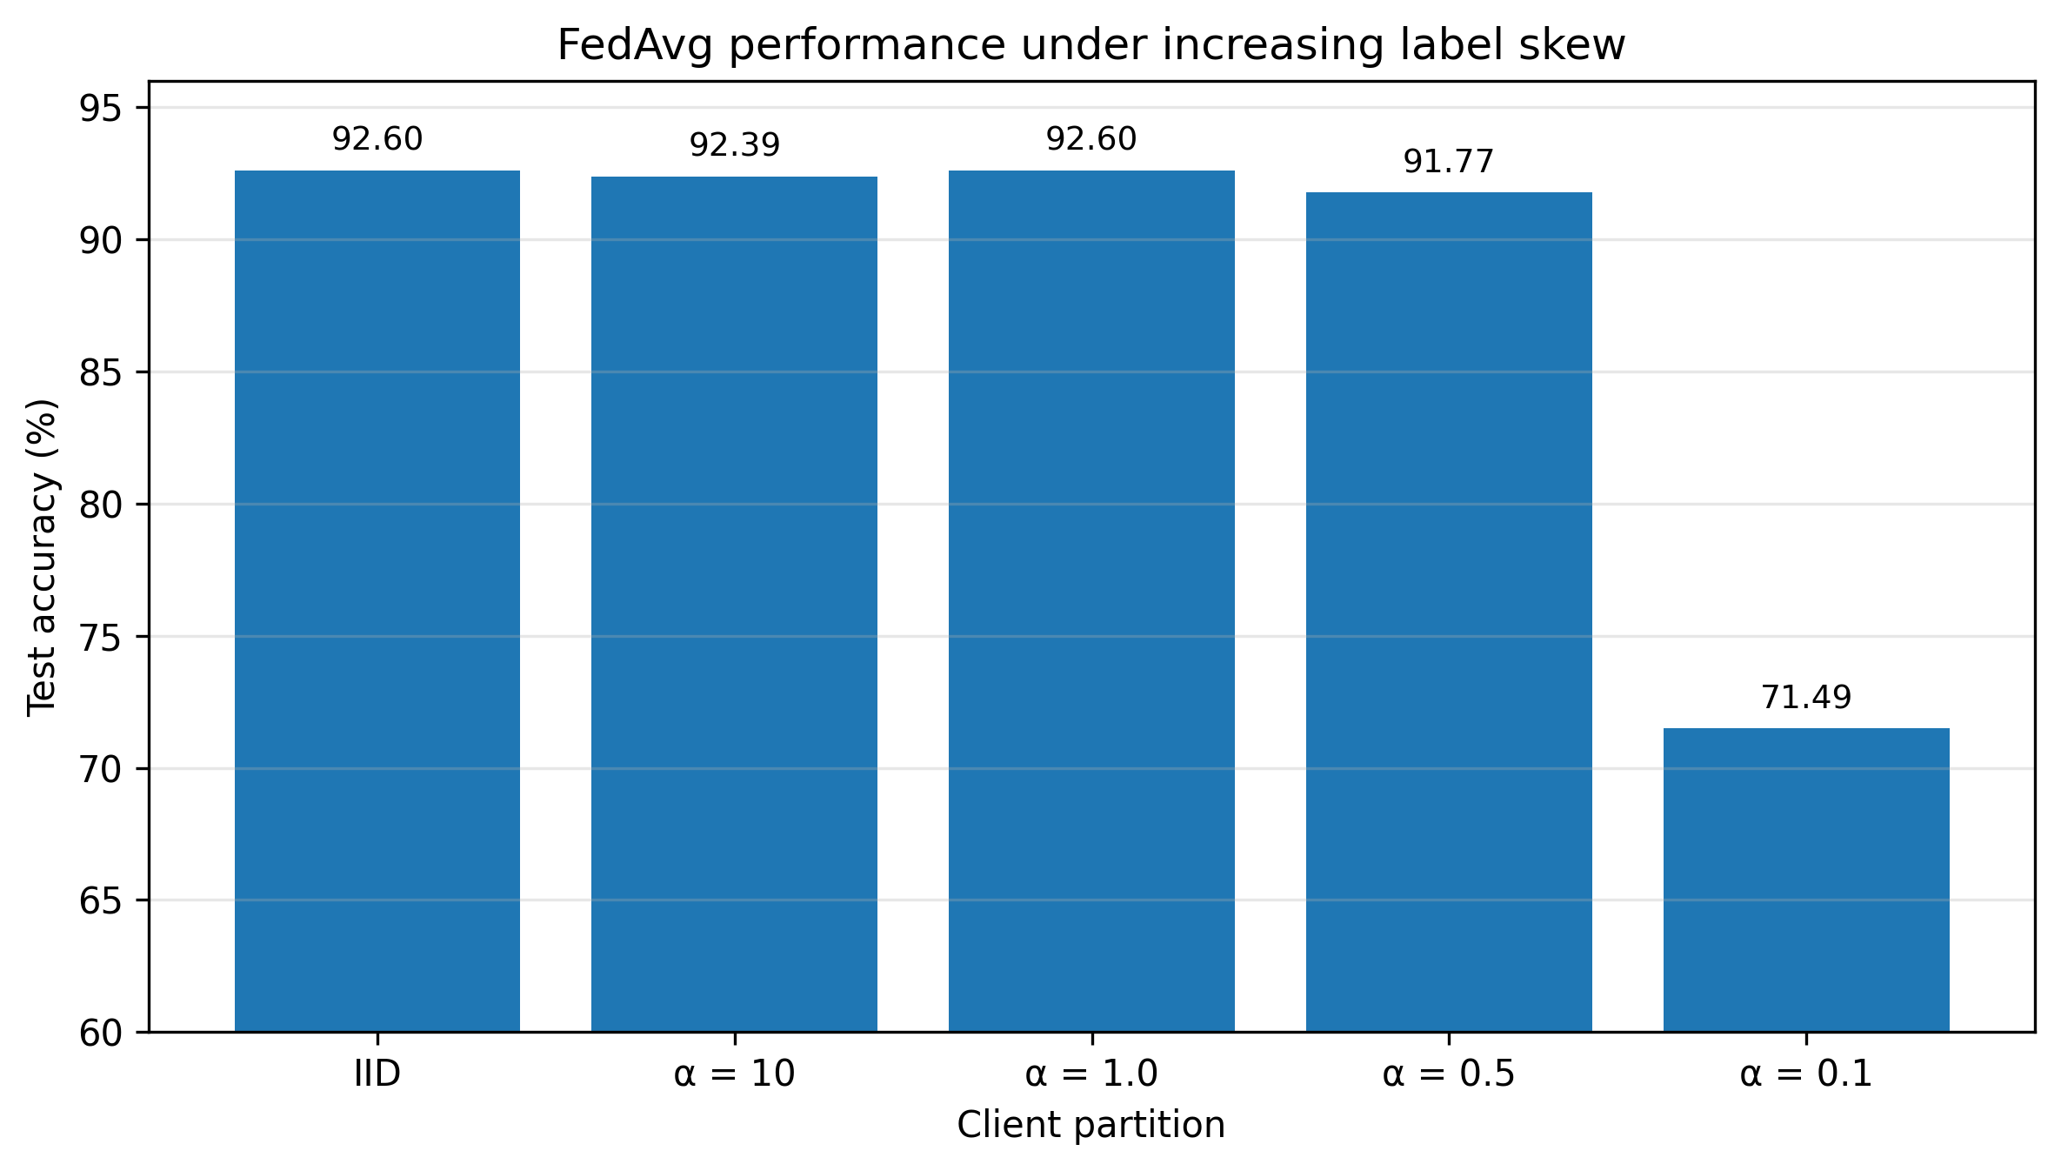
Figure 2. FedAvg test accuracy under increasing label skew. Performance remains close to IID until the most heterogeneous α = 0.1 partition.
These results show that FedAvg did not fail simply because the data were Non-IID. Under full participation and one local epoch, it tolerated mild and moderate label skew but reached a clear robustness boundary under the extreme partition.

3.3 Strictly Paired FedProx Results
Table 3. Strictly paired FedProx results.
Partition | Configuration | Test Accuracy | Macro-class Accuracy | Test Loss
α = 0.1 | μ = 0 | 77.51% | 73.60% | 0.7233
α = 0.1 | μ = 0.1 | 84.52% | 80.79% | 0.5331
α = 0.5 | μ = 0 | 87.36% | 82.46% | 0.4941
α = 0.5 | μ = 0.1 | 91.81% | 87.80% | 0.3461

The paired comparison was evaluated separately from the historical Stage 1B Adam results because both FedProx configurations used SGD. At α = 0.1, μ = 0.1 increased test accuracy by 7.02 percentage points and macro-class accuracy by 7.19 percentage points, while reducing test loss from 0.7233 to 0.5331. At α = 0.5, test accuracy increased by 4.46 percentage points, macro-class accuracy increased by 5.35 percentage points, and test loss also decreased. The larger gain under α = 0.1 is consistent with proximal regularisation becoming more useful as client objectives diverge.
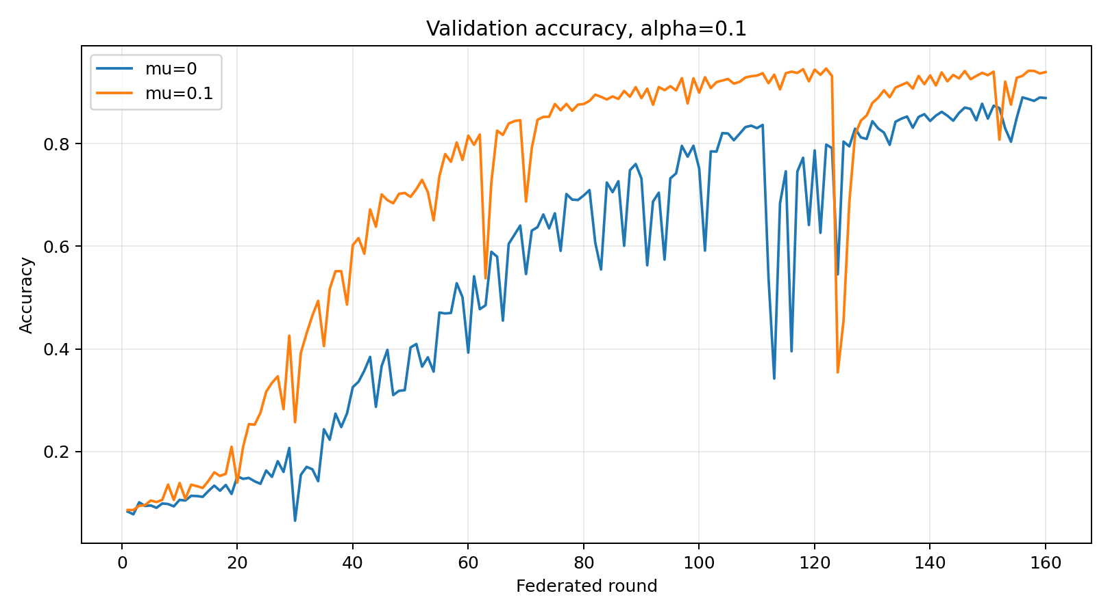
Figure 3. Validation accuracy for the matched μ = 0 and μ = 0.1 configurations under α = 0.1.
The μ = 0.1 model reached a best validation accuracy of 94.64%, compared with 89.02% for μ = 0. Although both trajectories fluctuated, the proximal configuration generally remained above the control during the later rounds.
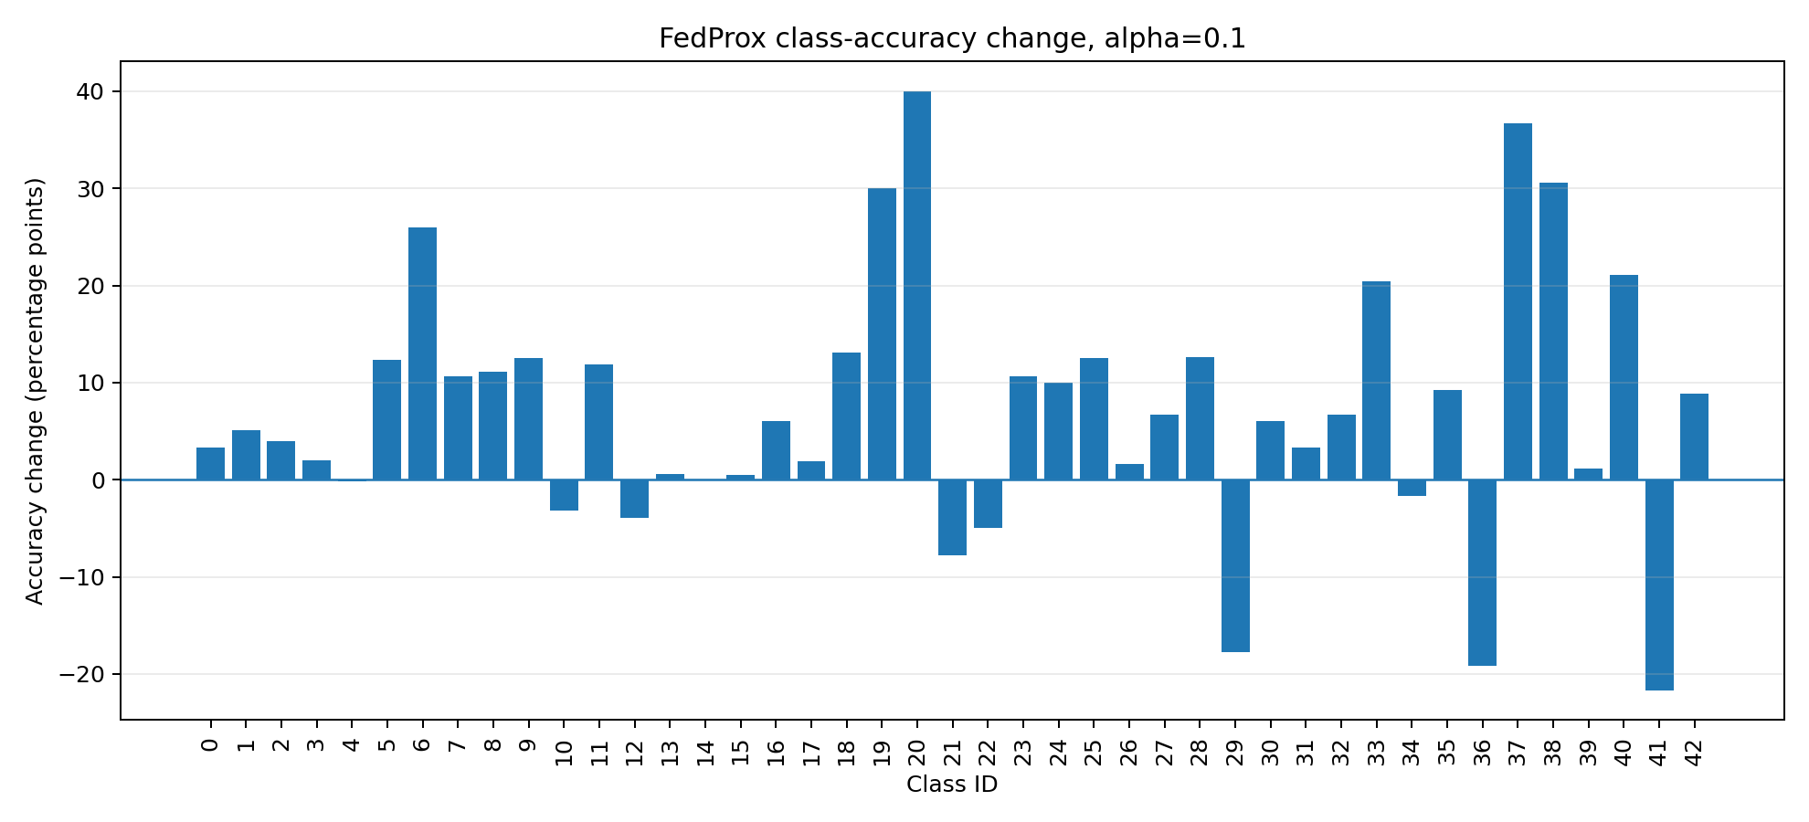
Figure 4. Per-class accuracy change produced by μ = 0.1 relative to μ = 0 under α = 0.1. Positive values indicate improvement.
The improvement was not limited to a small number of frequent classes. Under α = 0.1, 33 of 43 classes improved, nine declined, and one was unchanged. Under α = 0.5, 32 classes improved, six declined, and five were unchanged. Nevertheless, the benefit was not uniform: class 0 improved only from 0% to 3.33%, and several other classes deteriorated. FedProx therefore reduced, but did not eliminate, class-level failure.
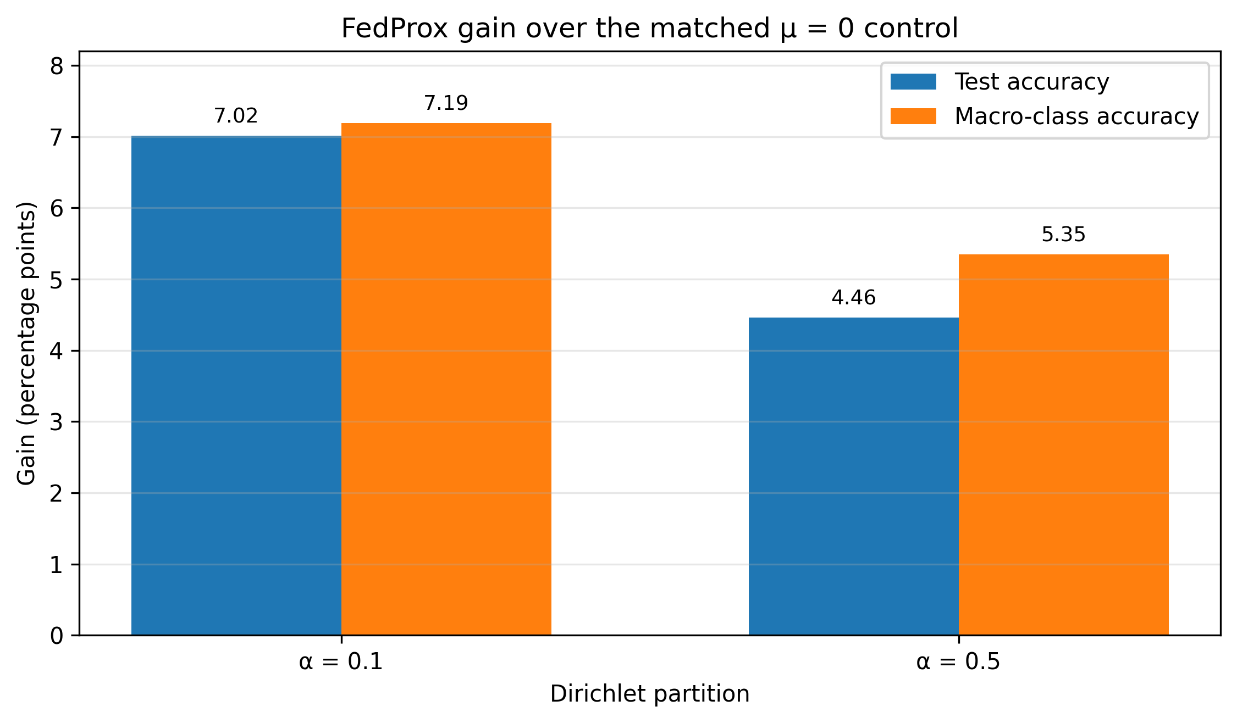
Figure 5. Test-accuracy and macro-class-accuracy gains from μ = 0.1 over the matched μ = 0 control.

4. Discussion
The results demonstrate that Non-IID data should not be treated as a single condition with a simple successful-or-failed outcome. In the present setting, FedAvg remained effective under mild and moderate label skew and deteriorated sharply only under α = 0.1. The practical effect of heterogeneity therefore depended on its strength and on the training conditions, including full participation and only one local epoch.
The difference between test accuracy and macro-class accuracy was also important. At α = 0.5, the overall metric changed little while the class-balanced metric declined more noticeably. At α = 0.1, several classes reached zero accuracy. For traffic-sign recognition, a low-frequency class may still represent a safety-relevant sign, so a model with acceptable overall accuracy can remain unreliable for particular categories. Macro-class, per-class, and confusion-matrix analysis consequently provided information that overall accuracy alone could not show.
The FedProx findings should be interpreted through the matched μ = 0 versus μ = 0.1 comparison. Directly comparing the historical Adam FedAvg run with the SGD FedProx run would mix the effect of the proximal term with the effect of the optimiser. Within the matched trainer, all three reported test metrics improved under both partitions. The greater improvement at α = 0.1 is consistent with the role of the proximal penalty: when local objectives differ more strongly, limiting excessive deviation from the global model may reduce conflicting client updates.
This explanation remains conditional. The experiments did not directly measure client drift at every local step, and some classes still declined. The results therefore support proximal regularisation in the evaluated settings rather than proving that FedProx resolves heterogeneous federated learning generally. A further engineering lesson is that implementation validity must be established before interpreting algorithmic behaviour. The earlier Batch-Normalisation failure was caused by mishandled moving statistics, not by FedAvg itself. Reliable checkpoints, fixed partitions, matched initialisation, and aggregation checks were consequently part of the research design rather than merely software housekeeping.

5. Limitations and Future Work
The first limitation is statistical coverage. All formal experiments used one partition and training seed. Fixed data and initialisation enabled reproducible paired comparisons, but they did not measure variation across alternative client assignments or random runs. The reported improvements should therefore be regarded as evidence from the evaluated setting, not as statistically general conclusions. The highest-priority extension is to repeat the main FedAvg and FedProx experiments with several seeds and report means, standard deviations, and confidence intervals.
The simulated environment was also relatively controlled. It contained five clients, every client participated in every round, and each client trained for one local epoch. These choices reduced sampling noise and local drift, but they are less demanding than realistic deployments. Future stress tests should include more clients, partial participation, unequal client sizes, drop-out, and additional local epochs.
The study considered label skew only. Real vehicles may also differ in camera quality, illumination, weather, road type, viewpoint, and image blur. Such feature or domain heterogeneity is not captured fully by a Dirichlet label partition. Controlled visual transformations or multi-domain road datasets would allow this axis to be studied separately.
Finally, FedProx was the only completed optimisation extension. SCAFFOLD and MOON use different mechanisms to control local updates or representations, while FedBN is more appropriate for client-specific feature distributions. These methods should be tested under the same fixed data, model, budget, and evaluation protocol. Communication compression should then be added as a separate axis, measuring both predictive performance and transmitted bytes. Statistical repetition and participation stress tests should take priority over adding many algorithms at once.

6. Conclusion
This study examined how label-distribution heterogeneity affects federated traffic-sign recognition and whether FedProx can mitigate the resulting degradation. Under IID, FedAvg substantially outperformed independent Local-only models and achieved performance comparable to centralised training. Controlled Dirichlet experiments showed that FedAvg remained robust under mild and moderate skew, but suffered sharp overall and class-level degradation under the extreme α = 0.1 partition.
In strictly matched experiments, μ = 0.1 improved test accuracy, macro-class accuracy, and test loss relative to μ = 0 under both evaluated partitions, with a larger gain under stronger heterogeneity. However, several classes remained weak or declined, so FedProx provided partial rather than complete mitigation. Overall, the project shows that reliable federated-learning evaluation requires controlled comparisons, class-level metrics, and explicit limits on interpretation. The results provide a reproducible foundation for multi-seed validation, stronger client-participation stress tests, and later comparison with additional Non-IID algorithms.

References
[1] H. B. McMahan, E. Moore, D. Ramage, S. Hampson, and B. Agüera y Arcas, “Communication-efficient learning of deep networks from decentralized data,” in Proceedings of the 20th International Conference on Artificial Intelligence and Statistics, PMLR, vol. 54, pp. 1273–1282, 2017.
[2] T. Li, A. K. Sahu, M. Zaheer, M. Sanjabi, A. Talwalkar, and V. Smith, “Federated optimization in heterogeneous networks,” Proceedings of Machine Learning and Systems, vol. 2, pp. 429–450, 2020.
[3] J. Stallkamp, M. Schlipsing, J. Salmen, and C. Igel, “The German Traffic Sign Recognition Benchmark: A multi-class classification competition,” in 2011 International Joint Conference on Neural Networks, pp. 1453–1460, 2011, doi: 10.1109/IJCNN.2011.6033395.
[4] T.-M. H. Hsu, H. Qi, and M. Brown, “Measuring the effects of non-identical data distribution for federated visual classification,” arXiv:1909.06335, 2019.
[5] P. Kairouz, H. B. McMahan, et al., “Advances and open problems in federated learning,” Foundations and Trends in Machine Learning, vol. 14, nos. 1–2, pp. 1–210, 2021, doi: 10.1561/2200000083.

